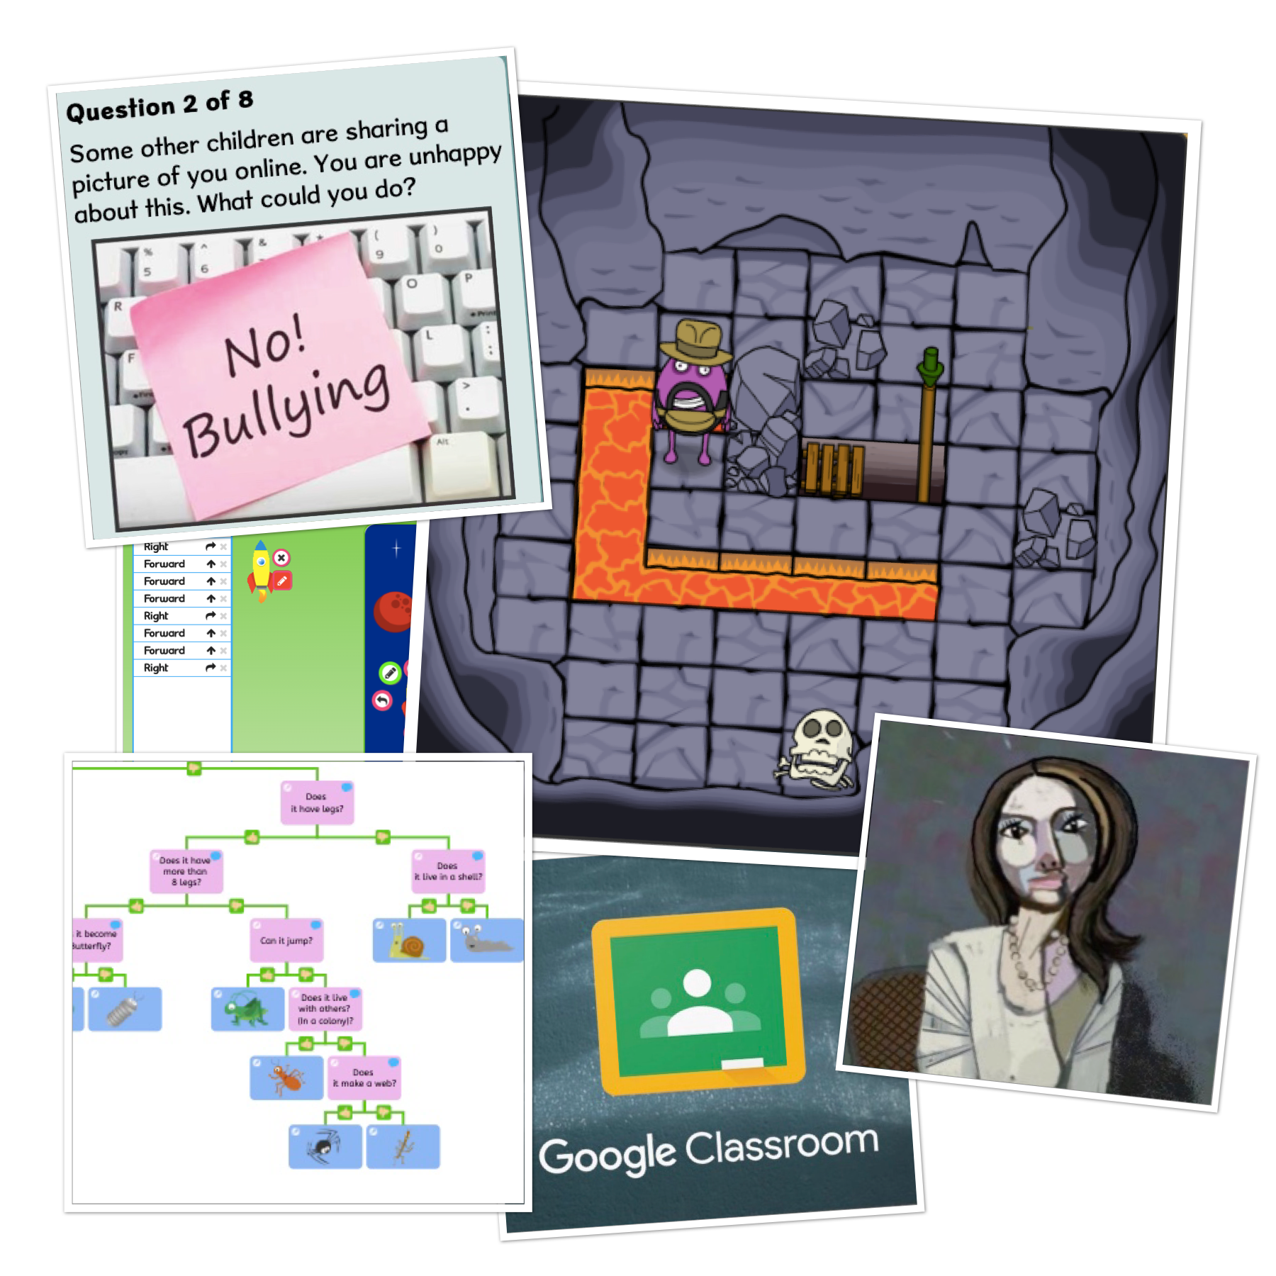


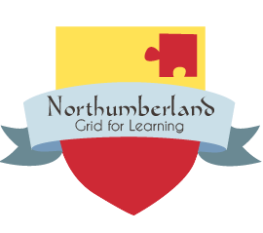
Using School360 to Deliver The NCCE Computing Curriculum
The National Centre for Computing Education KS1 - KS2 Schemes of work

This scheme of work has been created by the National Centre for Computing, funded by the Department for Education, covering the KS1 - KS4 computing curriculum. The National Centre for Computing aims to have 6 units of work available for each year group covering the full curriculum.

The scheme of work covers the 3 areas of the computing national curriculum

- Digital literacy
- Computer Science
- Information Technology

This is a lengthy document, intended to be viewed online. Use the clickable links within the document body or navigate the sections using the document outline feature to the left of this page.

This document provides an overview of each unit and suggests how these can be implemented in Northumberland Schools using School360 and its tools and resources.

Users can then click from this document directly to the folder for their selected Computing unit. Each folder contains a comprehensive overview, detailed lesson plans and any worksheets needed for that particular unit. Learning graphs and assessment rubrics are also included.

EYFS

Computing is not included in the EYFS Statutory Framework and therefore not included in the NCCE scheme of work. However, there are many opportunities to introduce computational thinking, problem solving and creativity into the Early Years classroom.

We strongly recommend reading ‘Laying the foundations for computing in the early years’ by Miles Berry in which he summarises the importance of beginning to learn about the abundance of technology all around us and the benefits of having access to technology to play, create and collaborate in the Early Years classroom.

Schools in SLA1 have access to loan Bluebots with themed mats which lend themselves brilliantly to introducing computational thinking through storytelling and play.

In School360 there are a wide range of activities for your youngest pupils to enjoy in the classroom or at home that encourage creativity, problem solving and confident use of digital devices.

**NEW** Barefoot Computing has launched two Computational Thinking resources specifically for EYFS with a guide to computational thinking in the EYFS classroom. You can access these resources HERE.


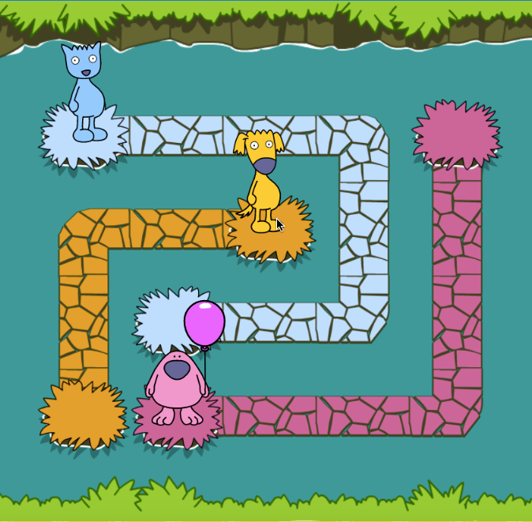

Key Stage 1 Overview

Pupils should be taught to: understand what algorithms are; how they are implemented as programs on digital devices; and that programs execute by following precise and unambiguous instructions create and debug simple programs use logical reasoning to predict the behaviour of simple programs use technology purposefully to create, organise, store, manipulate and retrieve digital content recognise common uses of information technology beyond school use technology safely and respectfully, keeping personal information private; identify where to go for help and support when they have concerns about content or contact on the internet or other online technologies.

Key Stage 1 Units

Year 1

- Unit 1.1 Computing Systems and Networks – Technology Around Us
- Unit 1.2 Creating Media – Digital Painting
- Unit 1.3 Creating Media – Digital Writing
- Unit 1.4 Data and information – Grouping data
- Unit 1.5 - Programming A - Moving a robot
- Unit 1.6 - Programming B - Introduction to animation

Year 2

- Unit 2.1 - Computing systems and networks - Information technology around us
- Unit 2.2 - Creating media - Digital photography
- Unit 2.3 - Creating media - Making music
- Unit 2.4 - Data and information - Pictograms
- Unit 2.5 - Programming A Robot Algorithms
- Unit 2.6 - Programming B An introduction to quizzes

Key Stage 2 Overview

Pupils should be taught to: design, write and debug programs that accomplish specific goals, including controlling or simulating physical systems; solve problems by decomposing them into smaller parts use sequence, selection, and repetition in programs; work with variables and various forms of input and output use logical reasoning to explain how some simple algorithms work and to detect and correct errors in algorithms and programs understand computer networks including the internet; how they can provide multiple services, such as the world wide web; and the opportunities they offer for communication and collaboration use search technologies effectively, appreciate how results are selected and ranked, and be discerning in evaluating digital content select, use and combine a variety of software (including internet services) on a range of digital devices to design and create a range of programs, systems and content that accomplish given goals, including collecting, analysing, evaluating and presenting data and information use technology safely, respectfully and responsibly; recognise acceptable/unacceptable behaviour; identify a range of ways to report concerns about content and contact.

Key Stage 2 Units

Year 3

- Unit 3.1 - Computing systems and networks - Connecting computers
- Unit 3.2 - Creating media - Stop frame animation
- Unit 3.3 - Creating media - Desktop publishing
- Unit 3.4 - Data and Information - Branching Databases
- Unit 3.5 - Programming A - Sequence in music
- Unit 3.6 - Programming B - Events and actions

Year 4

- Unit 4.1 - Computing systems and networks - The internet
- Unit 4.2 - Creating media - Audio editing
- Unit 4.3 - Creating media - Photo editing
- Unit 4.4 - Data and information: Data logging
- Unit 4.5 - Programming A - Repetition in shapes
- Unit 4.6 - Programming B - Repetition in games

Year 5

- Unit 5.1 Computing systems and networks – Sharing information
- Unit 5.2 Creating media – Vector drawing
- Unit 5.3 Creating media – Video editing
- Unit 5.4 - Data and Information - Flat File Databases
- Unit 5.5 - Programming A - Selection in Physical Computing
- Unit 5.6 - Programming B - Selection in Quizzes

Year 6

- Unit 6.1 Computing systems and networks – Communication
- Unit 6.2 Creating Media – 3D Modelling
- Unit 6.3 Creating media – Web page creation
- Unit 6.4 - Data and Information - Spreadsheets
- Unit 6.5 - Programming A - Variables in Games
- Unit 6.6 - Programming B - Sensing

Year 1

Unit 1.1 Computing systems and networks – Technology around us

Develop your learners’ understanding of technology and how it can help them. They will become more familiar with the different components of a computer by developing their keyboard and mouse skills, and also start to consider how to use technology responsibly.

N ICT Guidance
Key Resources:

Use the message board in School360 to share hyperlinks to resources such as the coding site used in lesson 2.

In lesson 3, consider using j2e paint as an alternative to paintz.app. It has a nice simple interface and a range of themed characters and backgrounds to choose from as well as a simple pen to practise changing colour and thickness.
In lessons 4 and 5 children can use j2mix to combine text and drawing. Busy Things, Computer Literacy has an internet safety poster making activity to use in Lesson 6.
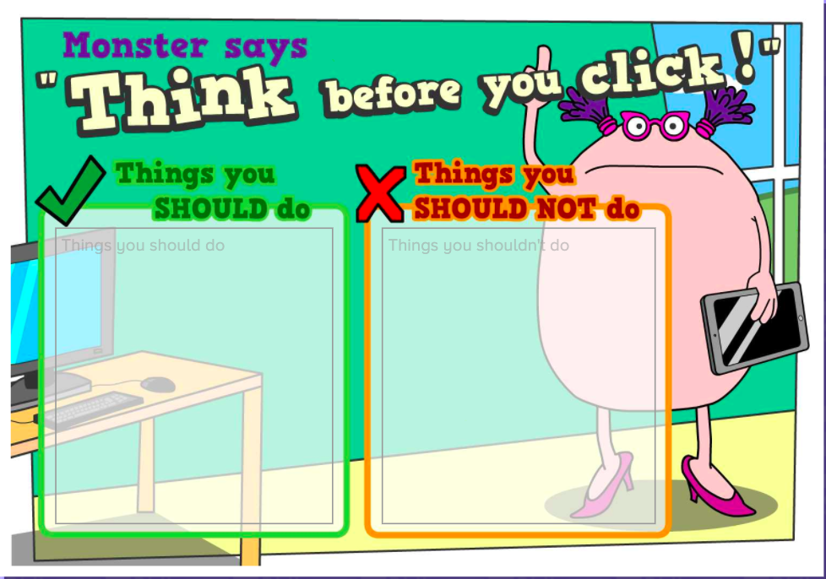
Additional suggested activities for starters, plenaries and home learning:

What is a Computer? BBC Bitesize
What are the main parts of a computer? BBC Bitesize

Busy Things, Computer Literacy has an excellent selection of activities to help children practise keyboard and mouse skills.

Unit 1.2 - Creating media – Digital painting

Explore the world of digital art and its exciting range of creative tools with your learners. Empower them to create their own paintings, while getting inspiration from a range of other artists. Conclude by asking them to consider their preferences when painting with, and without, the use of digital devices.

N ICT Guidance

Key Resources:
Busy Things has a large collection of art activities. Start with Busy Paint and Publisher in lesson 1, then build up to producing independent artwork in the style of Wassily Kandinsky in lessons 4 and 5 using the ‘Make a Masterpiece’ activities.

Additional suggested activities for starters, plenaries and home learning:
JiT Paint
Tate Kids - Tate Paint
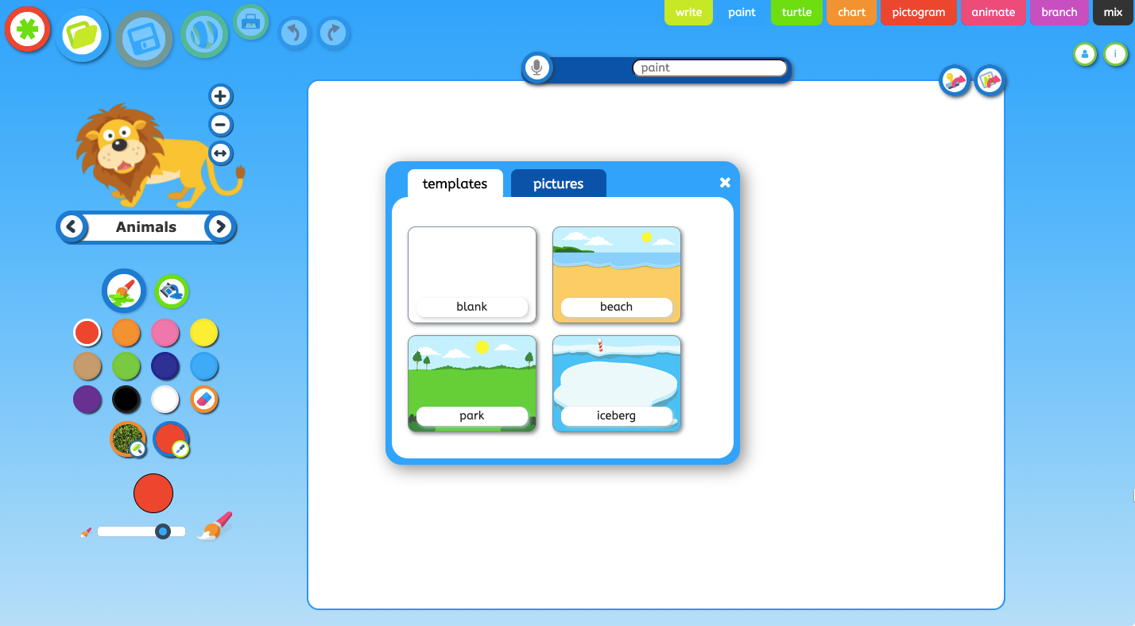

Unit 1.3 - Creating media – Digital writing

Promote your learners’ understanding of the various aspects of using a computer to create and change text. Learners will familiarise themselves with typing on a keyboard and begin using tools to change the look of their writing, and then they will consider the differences between using a computer and writing on paper to create text.

N ICT Guidance

Key Resources:
- Word processing packages j2office and Google Docs are both available in School360. The former may be simpler in terms of saving, locating and reopening work.

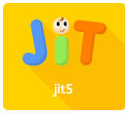


- JiT Write is a third option. It’s a simpler, stripped back writing tool. It doesn’t have the same features as full word processing software but may be a good option for those children who may struggle with office or docs.

Additional suggested activities for starters, plenaries and home learning:

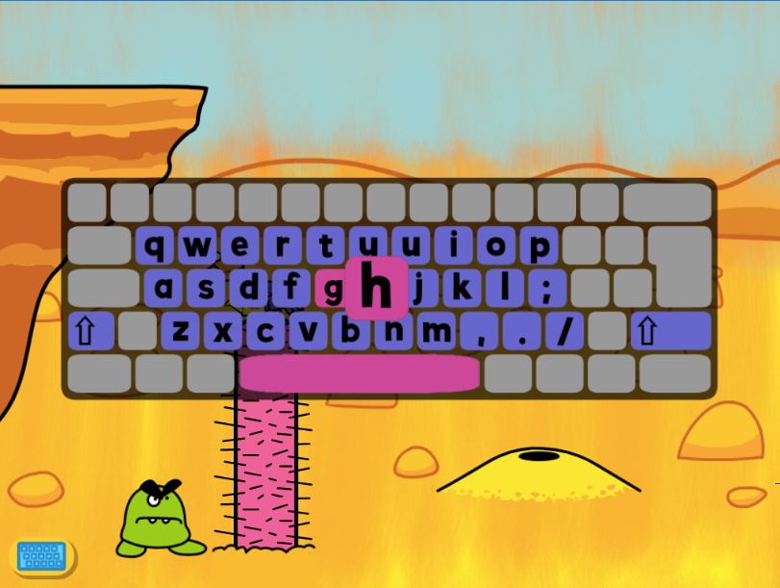
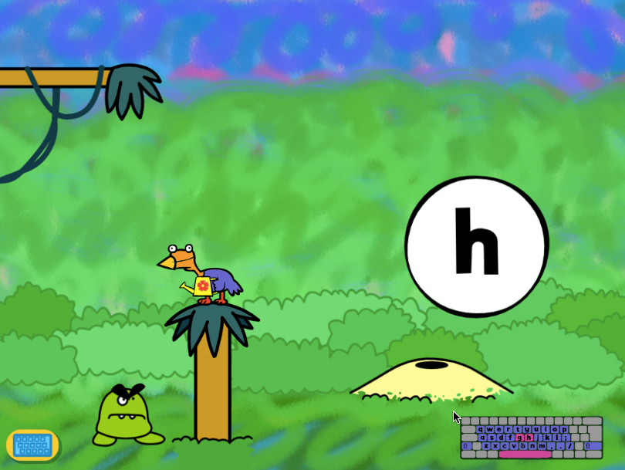
- Busy Things, Computer Literacy has an excellent selection of activities to help children practise keyboard and mouse skills.

Unit 1.4 Data and information – Grouping data

This unit introduces pupils to data and information. They will begin by using labels to put objects into groups, and labelling these groups. Pupils will demonstrate that they can count a small number of objects, before and after the objects are grouped. They will then begin to demonstrate their ability to sort objects into different groups, based on the properties they choose. Finally, pupils will use their ability to sort objects into different groups to answer questions about data.

N ICT Guidance

Key Resources:

Lessons 5 and 6 provide opportunities for pupils to practise mouse skills, dragging and dropping images using a provided template. While in Key Stage 2 you would share this using Google Classroom, in Key Stage 1 pupils may find it easier to access this file using j2e.
Download the file as a PowerPoint and then upload to your own j2e ‘my files’. Click on the green i icon, ensure the worksheet option is selected to give each pupil their own copy then select your class from the list. When pupils open the file it will open in j2office.

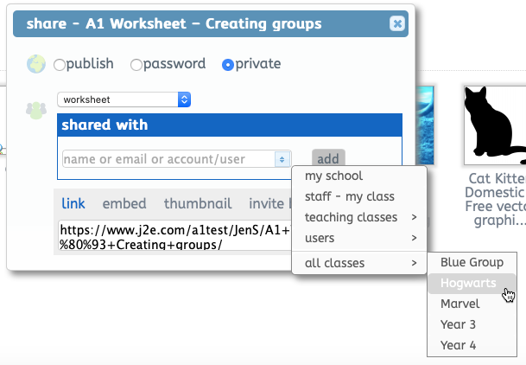
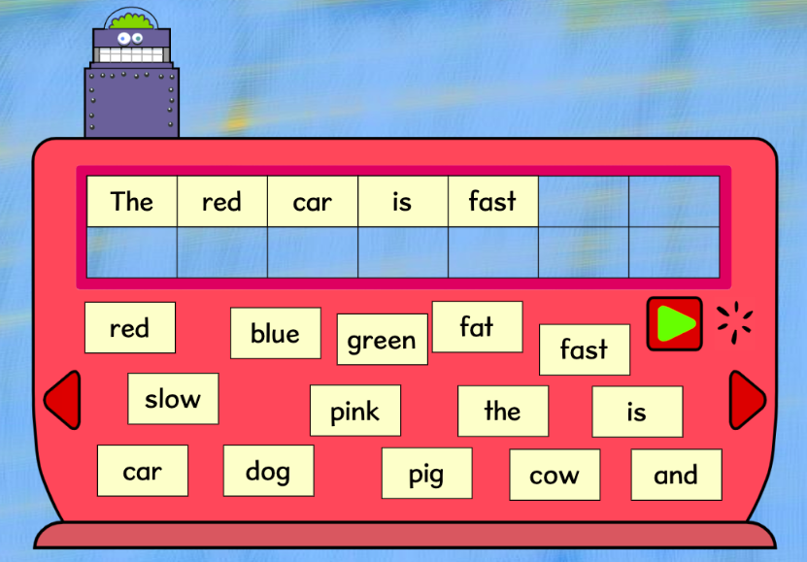

Additional suggested activities for starters, plenaries and home learning:

There are various activities included with Busy Things that allow children to practise accurate use of the mouse, including Word Robot found in the Computer Literacy collection.

Unit 1.5 Programming A – Moving a robot

This unit introduces learners to early programming concepts. Learners will explore using individual commands, both with other learners and as part of a computer program. They will identify what each floor robot command does and use that knowledge to start predicting the outcome of programs. The unit is paced to ensure time is spent on all aspects of programming and builds knowledge in a structured manner. Learners are also introduced to the early stages of program design through the introduction of algorithms.
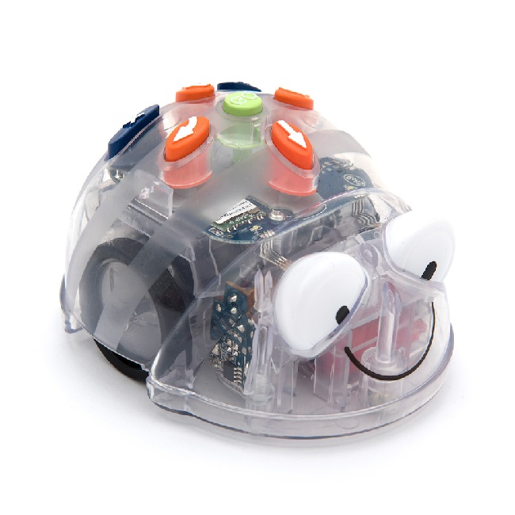
N ICT Guidance

Key Resources:
- Blue Bots and Rugged Robots available to loan for SLA1 schools.
- JIT Coding Platform (School360) Pupils write and debug an algorithm to move a sprite around the screen. Basic and advanced modes available.
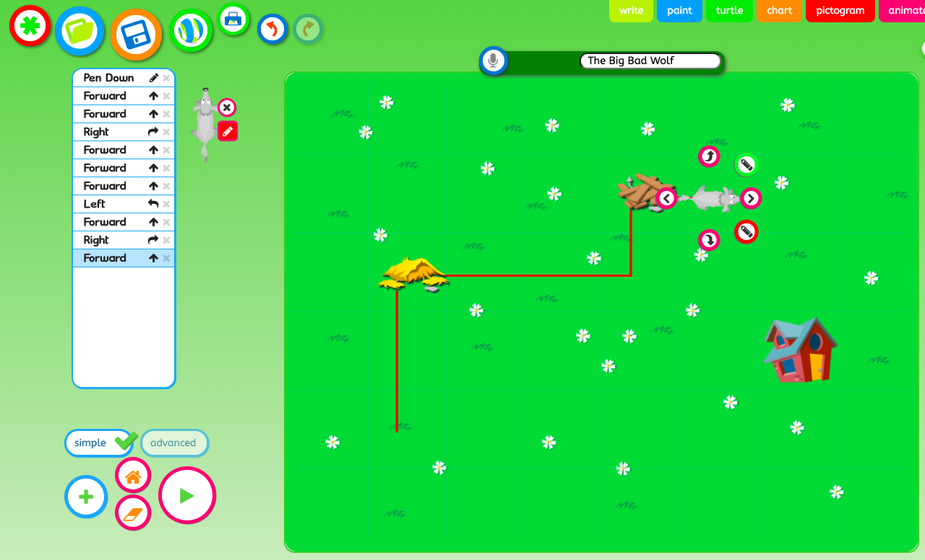

Additional suggested activities for starters, plenaries and home learning:
- The Little Red Ship and The Little Pirate Ship set in direct control (simple) mode
- Year One Busy Things Early Coding and Busy Code resources.
- BBC BItesize - How do you program a robot?

Unit 1.6 Programming B – Introduction to animation
(Programming A should be taught first)

This unit introduces learners to on screen programming through ScratchJr. Learners will explore the way a project looks by investigating sprites and backgrounds. They will use programming blocks to use, modify and create programs. Learners are also introduced to the early stages of program design through the introduction of algorithms.

N ICT Guidance
Key Resources:

- Scratch Jr is available as an app for Apple and Android devices. It is now also available as a computer download HERE.
- Teachers may wish to create a digital class book to document learning during programming units, taking photographs and video in which children explain what they have done and how their program works. This could be created using Google Slides in School360.

Additional suggested activities for starters, plenaries and home learning:

- Year One Busy Things Early Coding and Busy Code resources.
- BBC Bitesize - What is an algorithm?
- BBC Bitesize - What is Code?

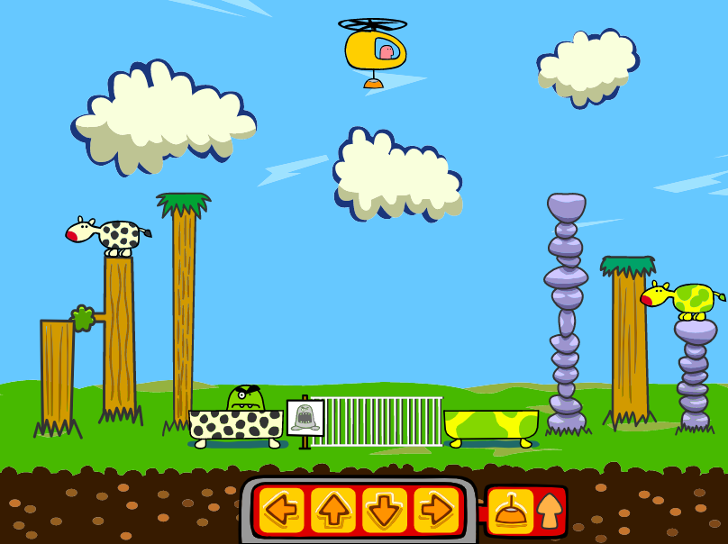
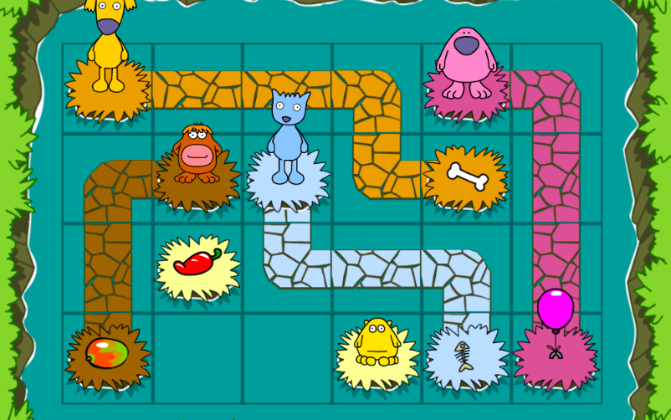

Year 2

Unit 2.1 - Computing systems and networks – Information technology around us

How is information technology (IT) being used for good in our lives? With an initial focus on IT in the home, learners explore how IT benefits society in places such as shops, libraries, and hospitals. Whilst discussing the responsible use of technology, and how to make smart choices when using it.

N ICT Guidance
Key Resources:

- For the sorting activity in lessons 2 and 3 you could give each pupil a copy of the document using Google Classroom. If your pupils aren't using this yet consider creating a document in j2e5, adding the images from the zip folder and sharing this with your class. Alternatively, put the activity up on the class white board to work collaboratively.

- To create a poster in lesson 5, use Busy Things to create and assign a custom project: Busy Paint and Publisher, when asked to choose a template, click ‘writing templates’ and choose a poster from the selection. Children can upload their photograph and add text.

Additional suggested activities for starters, plenaries and home learning:

- How do people use computers in different places? BBC Bitesize
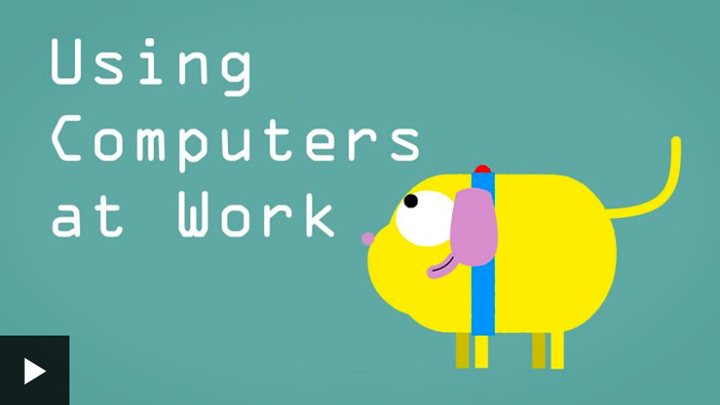

Unit 2.2 - Creating media – Digital photography

Through the lessons in this unit, learners will learn to recognise that different devices can be used to capture photographs and will gain experience capturing, editing, and improving photos. Finally, they will use this knowledge to recognise that images they see may not be real.

N ICT Guidance
Key Resources:

- We have added the Pixlr software as a resource in School360 for easy access.
- If you would like to save images taken by pupils, j2e has an upload function. Images can then be shared and used in work.

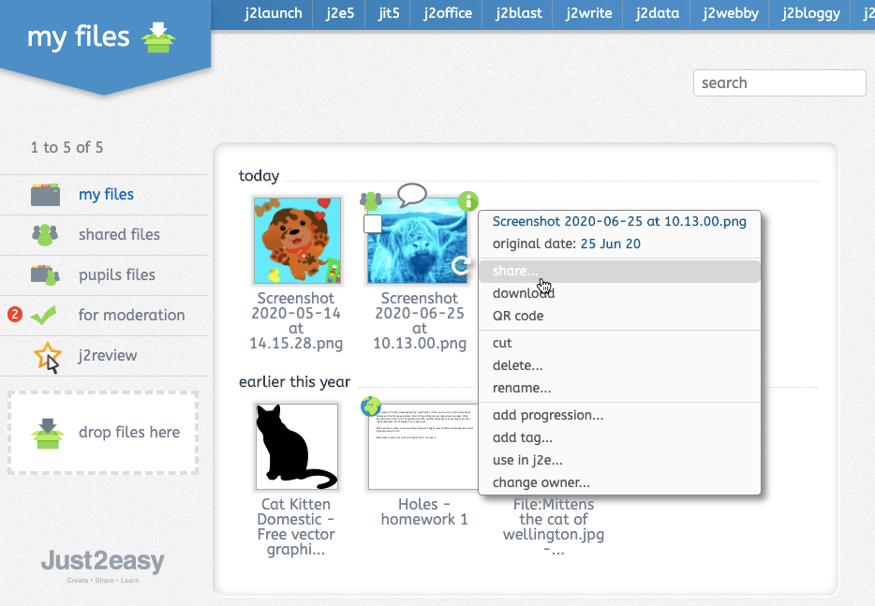

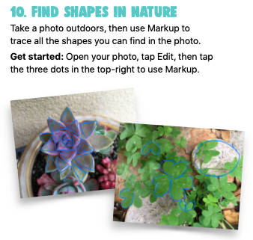
Additional suggested activities for starters, plenaries and home learning:

- The 30 Creative iPad Challenges document in School360 resources includes some fun photography activities which would make great homework tasks.
- Making a viewfinder, tips for composing your pictures.

Unit 2.3 Creating media – Making music

Learners will explore how music can make them think and feel. They will make patterns and use those patterns to make music with both percussion instruments and digital tools. They will also create different rhythms and tunes, using the movement of animals for inspiration. Finally, learners will share their creations and compare creating music digitally and non-digitally.

N ICT Guidance

Key Resources:

- Pupils can find Chrome Music Lab in the resources section of School360.
- In lesson 4 pupils are required to copy and paste the link to their Chrome Lab work so that they can access it again later. In j2e (J2Launch) pupils can click + and add a tile which, when clicked, will take them directly to their work.
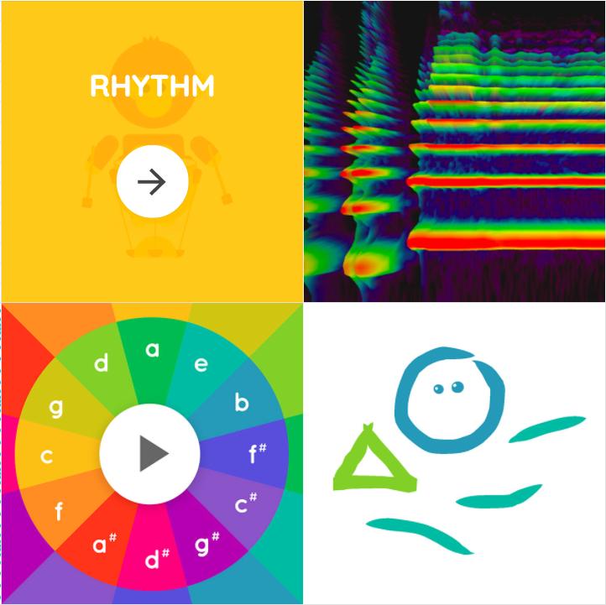
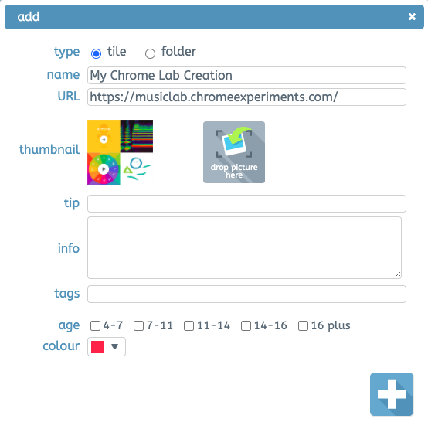

- Toward the end of this unit consider using the school/class blog (already set up for you in School360) to allow pupils to share their compositions with family and friends. They could create a post that includes a link to their Chrome Lab work and add images and text to show what they have learned.

Additional suggested activities for starters, plenaries and home learning:

- Busy Things has a large collection of activities covering composition, theory and notation and play and exploration.

Unit 2.4 - Data and information – Pictograms

This unit introduces the learners to the term ‘data’. Learners will begin to understand what data means and how this can be collected in the form of a tally chart. They will learn the term ‘attribute’ and use this to help them organise data. They will then progress onto presenting data in the form of pictograms and finally block diagrams. Learners will use the data presented to answer questions.

N ICT Guidance
Key Resources:

- Busy Graph Maker in Busy Things and j2data both allow children to create pictograms and bar graphs from scratch. Adding their own labels and titles.
- Both packages also offer a range of templates and themes.

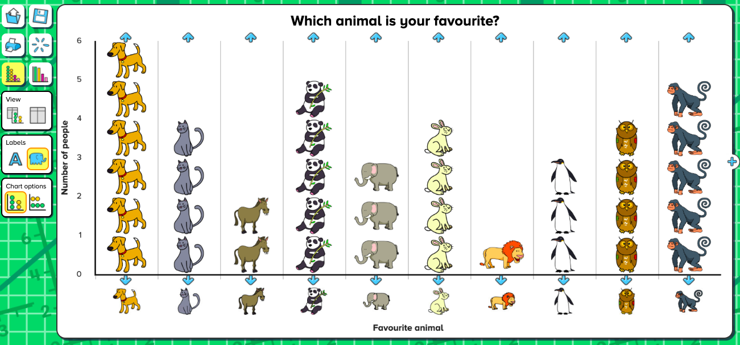

Additional suggested activities for starters, plenaries and home learning:
- BBC Bitesize How to Collect Data

Unit 2.5 - Programming A, Robot Algorithms

This unit develops pupils’ understanding of instructions in sequences and the use of logical reasoning to predict outcomes. Pupils will use given commands in different orders to investigate how the order affects the outcome. Pupils will also learn about design in programming. They will develop artwork and test it for use in a program. They will design algorithms and then test those algorithms as programs and debug them.

N ICT Guidance
Key Resources:

- Teachers may wish to create a digital class book to document learning during programming units, taking photographs and video in which children explain what they have done and how their program works. This could be created using Google Slides in School360 and then shared with parents.

Additional suggested activities for starters, plenaries and home learning:
- The Little Red Ship and The Little Pirate Ship set in coding (advanced) mode.
- Barefoot Home Learning Activities - Story Sequencing (algorithms)
- BBC Bitesize - What is a computer bug?
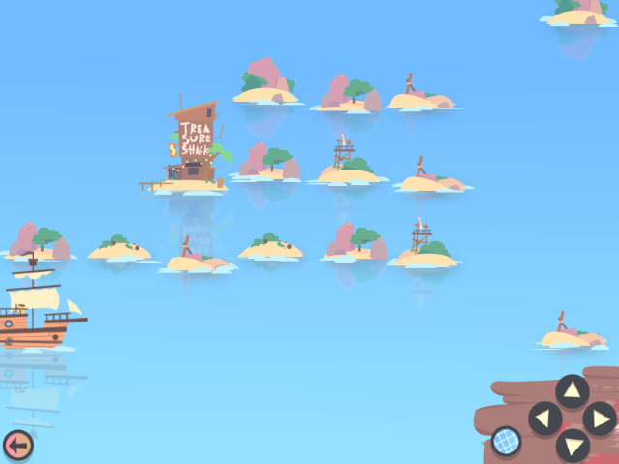

Unit 2.6 - Programming B, An introduction to quizzes

This unit initially recaps on learning from the Year 1 Scratch Junior unit ‘Programming B - Introduction to animation’ Learners begin to understand that sequences of commands have an outcome and make predictions based on their learning. They use and modify designs to create their own quiz questions in ScratchJr and realise these designs in ScratchJr using blocks of code. Finally, learners evaluate their work and make improvements to their programming projects.

N ICT Guidance
Key Resources:

- Teachers may wish to create a digital class book to document learning during programming units, taking photographs and video in which children explain what they have done and how their program works. This could be created using Google Slides in School360 and then shared with parents.
- Scratch Jr is available as an app for Apple and Android devices.

Additional suggested activities for starters, plenaries and home learning:
- Year Two Busy Things Early Coding and Busy Code resources.
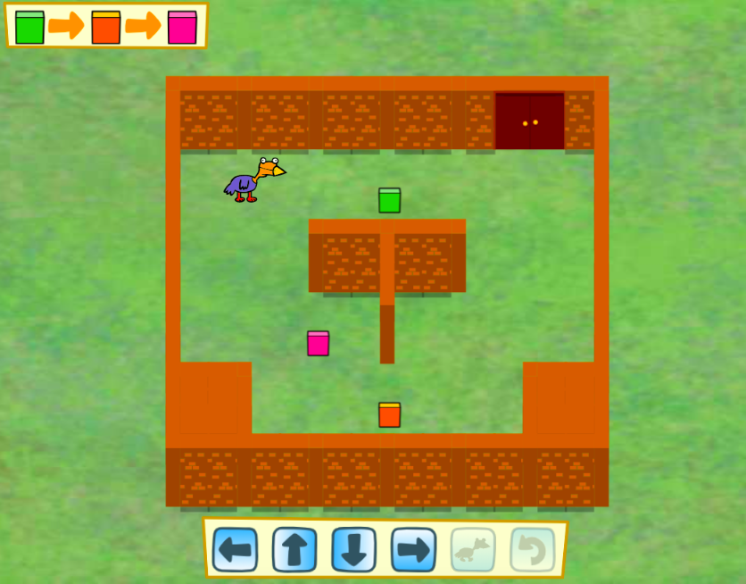
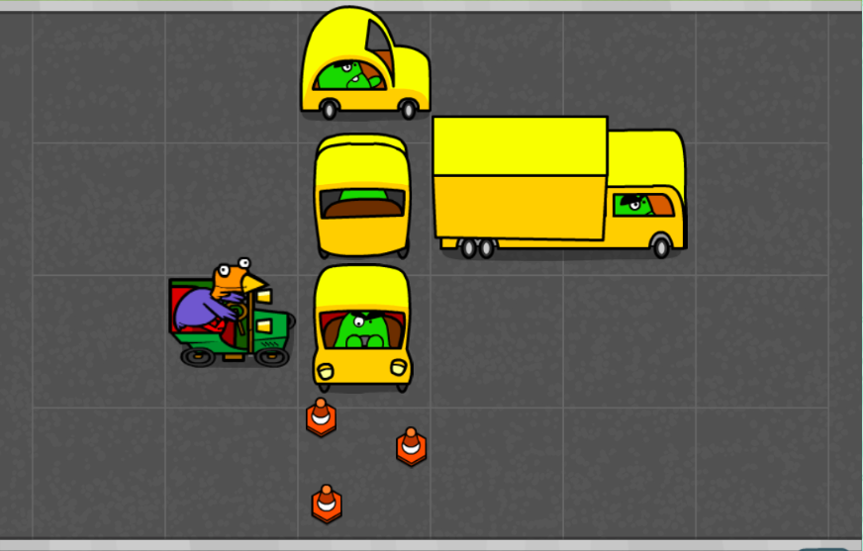
- Barefoot Interactive Game: Sorting it out (Logic and algorithms)

Year 3

Unit 3.1 - Computing systems and networks – Connecting computers

Challenge your learners to develop their understanding of digital devices, with an initial focus on inputs, processes, and outputs. Start by comparing digital and non-digital devices, before introducing them to computer networks that include network infrastructure devices like routers and switches.

N ICT Guidance

Key Resources:

- Google Classroom can be used to distribute materials such as worksheets if you wish these to be kept electronically.


Additional suggested activities for starters, plenaries and home learning:

- BBC Bitesize website - How does the Internet work?
- BBC Bitesize website - What is the world wide web?

Unit 3.2 - Creating media – Animation

During this unit, learners will use a range of techniques to create a stop frame animation using tablets. Next, they will apply those skills to create a story-based animation. This unit will conclude with learners adding other types of media to their animation, such as music and text.

N ICT Guidance
Key Resources:

- Unit suggests using iPads and iMotion App (free).
- Teachers could use JIT - Animation to create animations, the same tools are available. This will work on all devices with an internet connection and allows teachers to view the work children save using the pupil files.
- School360 Google Classroom can be used to distribute all learning resources.

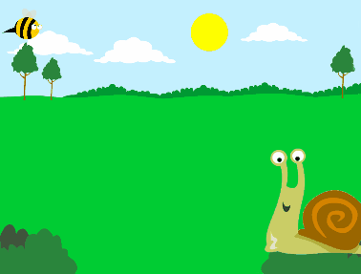

Additional suggested activities for starters, plenaries and home learning:

- Use of JIT animation allows children to access all materials from home.
- BBC Bitesize - How Does Animation Work?

Unit 3.3 Creating media – Desktop publishing

During this unit, learners will become familiar with the terms ‘text’ and ‘images’ and understand that they can be used to communicate messages. They will use desktop publishing software and consider careful choices of font size, colour and type to edit and improve premade documents. Learners will be introduced to the terms ‘templates’, ‘orientation’, and ‘placeholders’ and begin to understand how these can support them in making their own template for a magazine front cover. They will start to add text and images to create their own pieces of work using desktop publishing software. Learners will look at a range of page layouts thinking carefully about the purpose of these and evaluate how and why desktop publishing is used in the real world.

N ICT Guidance

Key Resources:

- Adobe Spark - Allows use across all devices.
- J2E has the J25 desktop publishing tool which allows students to save the work electronically but still allow the teacher to view this via the pupils folder.
- J2 Data - can be used to create digital charts.

- Busy Things - Busy Paint and Publisher tools also available and will work on all devices with an internet connection.


Additional suggested activities for starters, plenaries and home learning:

- BBC Bitesize website - How do Digital images work?
- BBC Bitesize website - Creating and understanding charts

Unit 3.4 - Data and Information - Branching Databases

During this unit, learners will develop their understanding of what a branching database is and how to create one. They will gain an understanding of what attributes are and how to use them to sort groups of objects by using yes/no questions. The learners will create physical and on-screen branching databases. Finally, they will evaluate the effectiveness of branching databases and will decide what types of data should be presented as a branching database.

N ICT Guidance

Key Resources:
- Ensure pupils log into School360 to access the j2e branching database tool. This will allow them to save their work and reopen in subsequent lessons. As a teacher you can access pupil files to view work and leave feedback.

Additional suggested activities for starters, plenaries and home learning:
- Toward the end of this unit children consider how different types of data can be presented. Busy Things has a range of prefilled templates that allow pupils to record and present data in different ways.
- Barefoot Computing ‘Colourful kits’ (data)

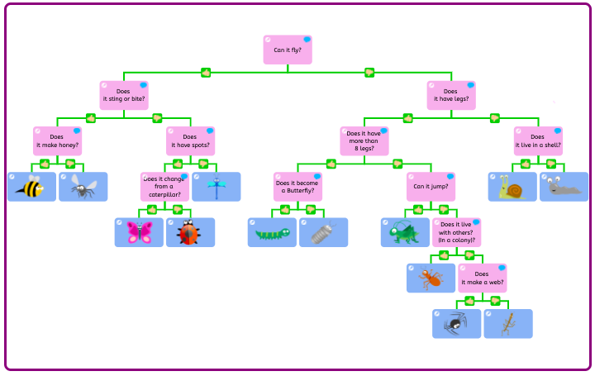

Unit 3.5 - Programming A – Sequence in music

This unit explores the concept of sequencing in programming through Scratch. It begins with an introduction to the programming environment, which will be new to most learners. They will be introduced to a selection of motion, sound, and event blocks which they will use to create their own programs, featuring sequences. The final project is to make a representation of a piano. The unit is paced to focus on all aspects of sequences, and make sure that knowledge is built in a structured manner. Learners also apply stages of program design through this unit.

N ICT Guidance
Key Resources:
- Scratch - Create a teacher account using your School360 Google account (username@school360.co.uk) Once created, you can invite students to a class. This allows the teacher to see all of the students' work created on the Scratch website. - Students also use School360 accounts to create their Scratch accounts.
- Google classroom is a great way of sharing links and resources with the students.
- J2Code could be used to test out newly gained programming skills in a different environment.
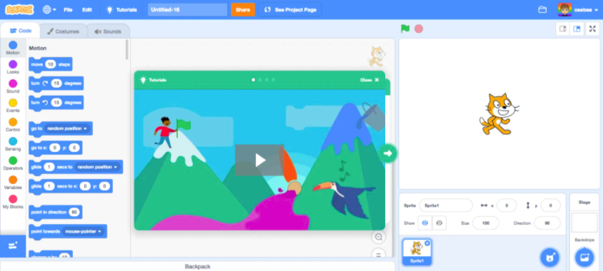
Additional suggested activities for starters, plenaries and home learning:

- Busy Code in Busy things (Year 3) is a great way for students to practise and apply their computational thinking skills.
- BBC Bitesize - Sequencing
- Scratch challenge activity in School360 resources - Challenges and Activities.

Unit 3.6 - Programming B - Events and actions

This unit explores the links between events and actions, whilst consolidating prior learning relating to sequencing. Learners will begin by moving a sprite in four directions (up, down, left and right). They will then explore movement within the context of a maze, using design to choose an appropriately sized sprite. This unit also introduces programming extensions, through the use of pen blocks. Learners are given the opportunity to draw lines with sprites and change the size and colour of lines. The unit concludes with learners designing and coding their own maze tracing program.

N ICT Guidance
Key Resources:
- Scratch - Create a teacher account using your School360 Google account (username@school360.co.uk) Once created, you can invite students to a class. This allows the teacher to see all of the students' work created on the Scratch website. - Students also use School360 accounts to create their Scratch accounts.
- Google classroom is a great way of sharing links and resources with the students.
- J2Code could be used to test out newly gained programming skills in a different environment.

Additional suggested activities for starters, plenaries and home learning:

- Make a flappy game at code.org
- BBC Bitesize - What is an algorithm?


Year 4

Unit 4.1 - Computing systems and networks – The internet

During this unit learners will apply their knowledge and understanding of networks, to appreciate the internet as a network of networks which need to be kept secure. They will learn that the World Wide Web is part of the internet, and be given opportunities to explore the World Wide Web for themselves to learn about who owns content and what they can access, add, and create. Finally they will evaluate online content to decide how honest, accurate, or reliable it is, and understand the consequences of false information.

N ICT Guidance

Key Resources:

- Use of School360 accounts to access Scratch classroom accounts.
- Use of J2E tools to create mind maps for Lesson 2.
- Google Classroom can be used to distribute materials such as worksheets if you wish these to be kept electronically.

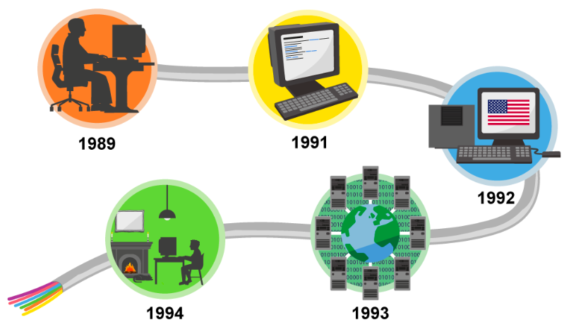
Additional suggested activities for starters, plenaries and home learning:

- BBC Bitesize website - How does the Internet work?
- BBC Bitesize website - What is the world wide web?

Unit 4.2 - Creating media – Audio editing

In this unit, learners will initially examine devices capable of recording digital audio, which will include identifying the input device (microphone) and output devices (speaker or headphones) if available. Learners will discuss the ownership of digital audio and the copyright implications of duplicating the work of others. In order to record audio themselves, learners will use Audacity to produce a podcast, which will include editing their work, adding multiple tracks, and opening and saving the audio files. Finally, learners will evaluate their work and give feedback to their peers.

N ICT Guidance

Key Resources:

- Devices with the ability to record sound is essential for this unit:
  - iPads: use the following apps to record sounds: Garage Band or Voice Memo.
  - Chromebooks: Apowersoft a free online audio recorder using the chromebooks built in microphone.
  - Windows based computers: Audacity which is free to download.
- Use of Google Classroom or J2E to create planning documents/ scripts.

Additional suggested activities for starters, plenaries and home learning:

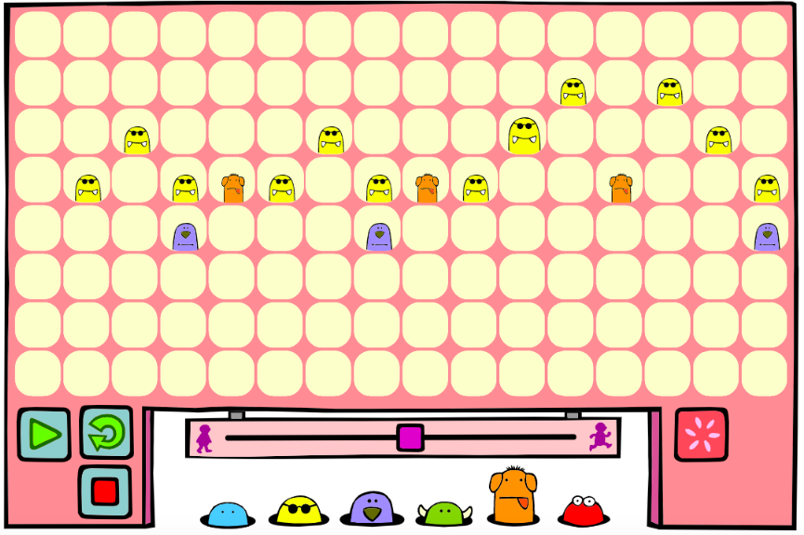
- Busy things KS2 music activities allow the compositions of sounds on any device with an internet connection.

Unit 4.3 - Creating media – Photo editing
In this unit, learners will develop their understanding of how digital images can be changed and edited, and how they can then be resaved and reused. They will consider the impact that editing images can have, and evaluate the effectiveness of their choices.

N ICT Guidance

Key Resources:
- We have added the Pixlr software as a resource in School360 for easy access.
- If you would like to save images taken by pupils, j2e has an upload function. Images can then be shared and used in work. Alternatively, upload with Google Drive.

Additional suggested activities for starters, plenaries and home learning:

- BBC Bitesize website - How do Digital images work?

- The 30 Creative iPad Challenges document in School360 resources includes some fun photography activities which would make great home learning tasks.

Unit 4.4 - Data and information, Data Logging

In this unit, pupils will consider how and why data is collected over time. Pupils will consider the senses that humans use to experience the environment and how computers can use special input devices called sensors to monitor the environment. Pupils will collect data as well as access data captured over long periods of time. They will look at data points, data sets, and logging intervals. Pupils will spend time using a computer to review and analyse data. Towards the end of the unit, pupils will pose questions and then use data loggers to automatically collect the data needed to answer those questions.

N ICT Guidance

Key Resources:
- If you don’t have data loggers in school, try the Google Science Journal app.
- A data file is shared with pupils in lesson 4, you could use Google Classroom to issue this file to pupils.
- In lesson 6 pupils could create their report digitally either using j2e5, j2Office or Google Docs. You could create a template and share this with the children via j2e or Google Classroom.

Additional suggested activities for starters, plenaries and home learning:
- As an extension activity, pupils could use the Busy Things graph maker tool to display their collected data and add this to their report.

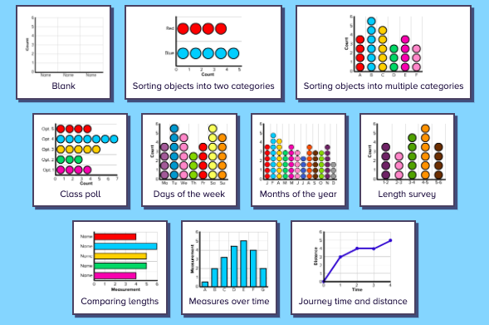

Unit 4.5 - Programming A: Repetition in Shapes

This unit is the first of the two programming units in Year 4, and looks at repetition and loops within programming. Pupils will create programs by planning, modifying, and testing commands to create shapes and patterns. They will use Logo, a text-based programming language.

N ICT Guidance

Key Resources:
- Login to School360 to access j2data and Logo, children can save work produced and as a teacher you can view all pupil work and provide feedback. You will find 3 levels of difficulty available to provide differentiation. You may find THIS introductory video helpful.

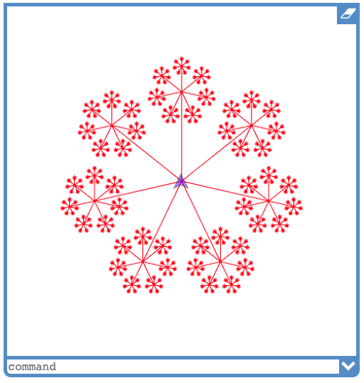
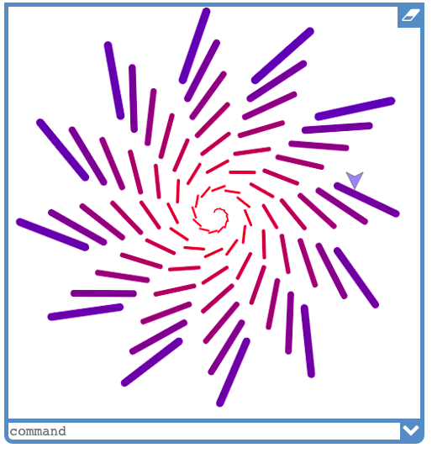
Additional suggested activities for starters, plenaries and home learning:
- THIS teacher guide explains repetition and its importance within the computing curriculum. See the linked Shapes and Crystal Flowers activity too. (login to Barefoot Computing to access link).
- BBC Bitesize on sequence, selection and repetition.
- Home Learning - Barefoot Decomposition Activity and worksheets.

Unit 4.6 - Programming B: Repetition in games

This unit explores the concept of repetition in programming using the Scratch environment. It begins with a Scratch activity similar to that carried out in Logo in Programming unit A, where learners can discover similarities between two environments. Learners look at the difference between count-controlled and infinite loops, and use their knowledge to modify existing animations and games using repetition. Their final project is to design and create a game which uses repetition, applying stages of programming design throughout.

N ICT Guidance

Key Resources:
- Scratch - Create a teacher account using your School360 Google account (username@school360.co.uk) Once created, you can invite students to a class. This allows the teacher to see all of the students' work created on the Scratch website. Students also use School360 accounts to create their Scratch accounts.
- Google classroom is a great way of sharing links and resources with the students.

Additional suggested activities for starters, plenaries and home learning:
- Hour of Code is great for self led home learning. Try this Star Wars activity which combines step by step coding challenges with motivational videos detailing how computer science is an integral part of the movie industry.

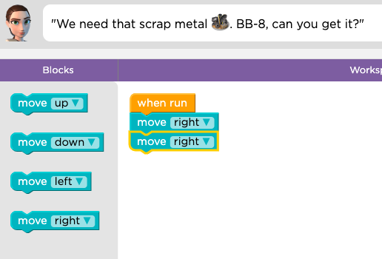
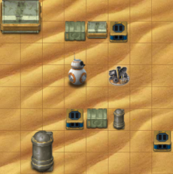

Year 5

Unit 5.1 - Computing systems and networks - Sharing information creating media

In this unit, learners will develop their understanding of computer systems and how information is transferred between systems and devices. Learners will consider small-scale systems as well as large-scale systems. They will explain the input, output, and process aspects of a variety of different real-world systems. Learners will also take part in a collaborative online project with other class members and develop their skills in working together online.

N ICT Guidance

Key Resources:
- Use of School360 Google Suite (Google slides/ docs) Option to use Google classroom to collate work and resources.
- Lesson 6 - Teachers encouraged to create a Scratch teacher account using School360 account - students can join the class using class code - option to share through Google classroom, using this option allows teachers to view the students work. Further guidance around creating and using Google classroom available in School360 - Resources - Teacher Pack.

Additional suggested activities for starters, plenaries and home learning:

- Online Safety - Think You know home activities for 8-10 year olds available in School360 ‘online safety’ pack.

Unit 5.2 - Creating media – Vector drawing

In this unit learners will find out that vector images are made up of shapes. They will learn how to use the different drawing tools and how images are created in layers. They will explore the ways in which images can be grouped and duplicated to support them in creating more complex pieces of work. This unit is planned using the Google Drawings app other alternative pieces of software are available.

N ICT Guidance

Key Resources:
- Use of School360 Google Suite (Google slides, docs and drawing) Option to use Google classroom to collate work and resources.
- If using iPads - Keynote for ipads using iOS12+ is also an option and allows the use of an Apple pencil and Stylus.
- Earlier lessons could use J2e5 - and using the shape tools if preferred.

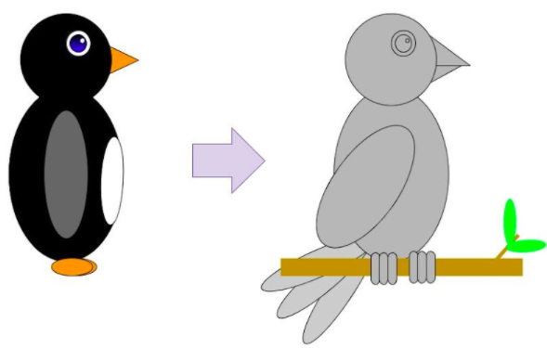

Additional suggested activities for starters, plenaries and home learning:
- BBC Bitesize - Digital Images

Unit 5.3 - Creating media – Video editing

This unit gives learners the opportunity to learn how to create short videos in groups. As they progress through this unit, they will be exposed to topic-based language and develop the skills of capturing, editing, and manipulating video. Active learning is encouraged through guided questions and by working in small groups to investigate the use of devices and software. Learners are guided with step-by-step support to take their idea from conception to completion. At the teacher’s discretion, the use of green screen can be incorporated into this unit. At the conclusion of the unit, learners have the opportunity to reflect on and assess their progress in creating a video.

N ICT Guidance

Key Resources:
- Green Screen training and loan of equipment available through SLA1
- Adobe Spark Video - will allow students to create video content with the use of titles, music and transitions etc on most devices with a camera and microphone.
- DoInk Green Screen - App for Apple iPads - excellent green screen functions to create video. The app does have a small cost.
- iMovie - App great for editing video that has already been recorded, also allows the user to add music, effects including green screen, titles and transitions.
- LitFilm Fest - excellent projects for cross curricular links for the basis of videos. Different units made free each academic year, available here.

Additional suggested activities for starters, plenaries and home learning:

- BBC Bitesize - Creating digital video and audio.

Unit 5.4 - Data and Information - Flat File Databases

This unit looks at how a flat-file database can be used to organise data in records. Pupils use tools within a database to order and answer questions about data. They create graphs and charts from their data to help solve problems. They use a real-life database to answer a question, and present their work to others.

N ICT Guidance

Key Resources:
- Use of J2E data and sample databases are available in school360 resources and then J2e icon, this will allow students to save their work for each of the lessons (**Note** going direct to J2E’s website will not allow students to save their work)
- Busy Things KS2 - Computing - ‘Busy Graph Maker’ is another option for creating visualizations of the data the students have been collecting.

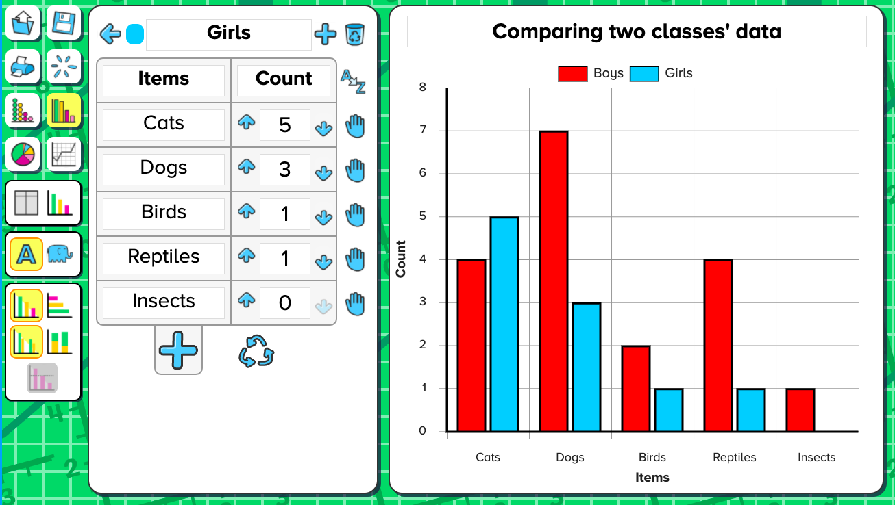
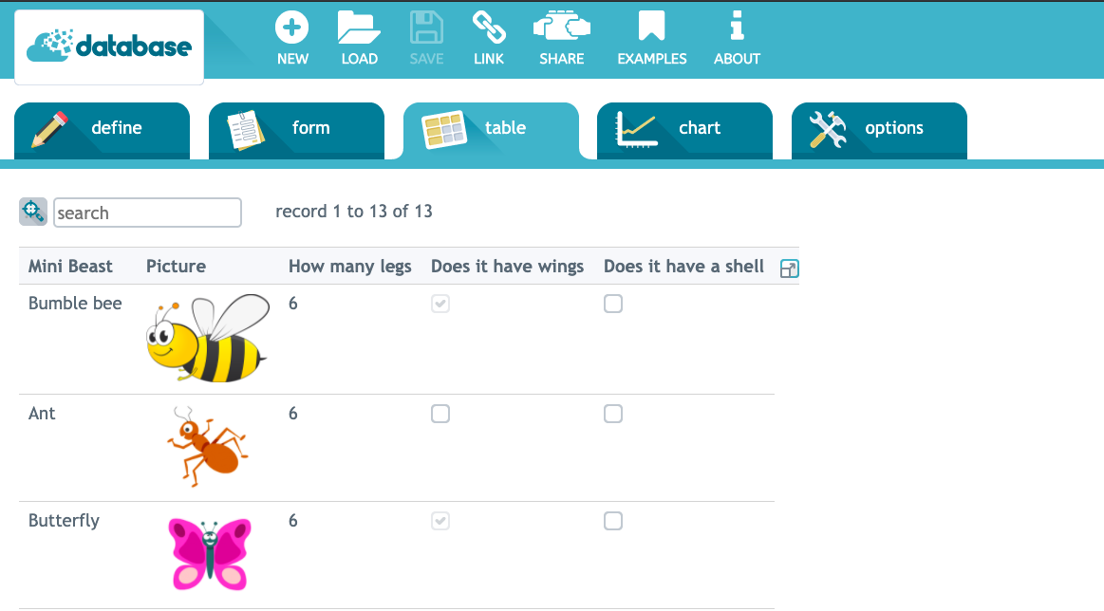

Additional suggested activities for starters, plenaries and home learning:

- BBC Bitesize - What is a Database?

Unit 5.5 - Programming A - Selection in Physical Computing

In this unit, learners will use physical computing to explore the concept of selection in programming through the use of the Crumble programming environment. Learners will be introduced to a microcontroller (Crumble controller) and learn how to connect and program components (including output devices- LEDs and motors) through the application of their existing programming knowledge. Learners are introduced to conditions as a means of controlling the flow of actions and make use of their knowledge of repetition and conditions when introduced to the concept of selection (through the if, then structure).

N ICT Guidance

Key Resources:

- Crumbles are available to loan for SLA1 schools but must be booked in advance.
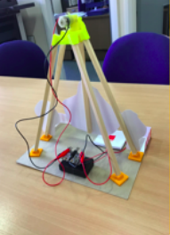
- A introduction to Crumbles course is also available to all SLA1 schools - For further details please contact: Julie.Keenlyside@northumberland.gov.uk

Additional suggested activities for starters, plenaries and home learning:

- BBC Bitesize - Controlling physical systems

Unit 5.6 - Programming B - Selection in Quizzes

In this unit, pupils develop their knowledge of selection by revisiting how conditions can be used in programs and then learning how the If… Then… Else structure can be used to select different outcomes depending on whether a condition is true or false. They represent this understanding in algorithms and then by constructing programs using the Scratch programming environment. They use their knowledge of writing programs and using selection to control outcomes to design a quiz in response to a given task and implement it as a program.

N ICT Guidance

Key Resources:

- Use of School360 Google Suite (Google slides/ docs) Option to use Google classroom to collate work and resources.
- Teachers encouraged to create a Scratch teacher account using School360 account - students can join the class using class code - option to share through Google classroom, using this option allows teachers to view the students work. Further guidance around creating and using Google classroom available in School360 - Resources - Teacher Pack.
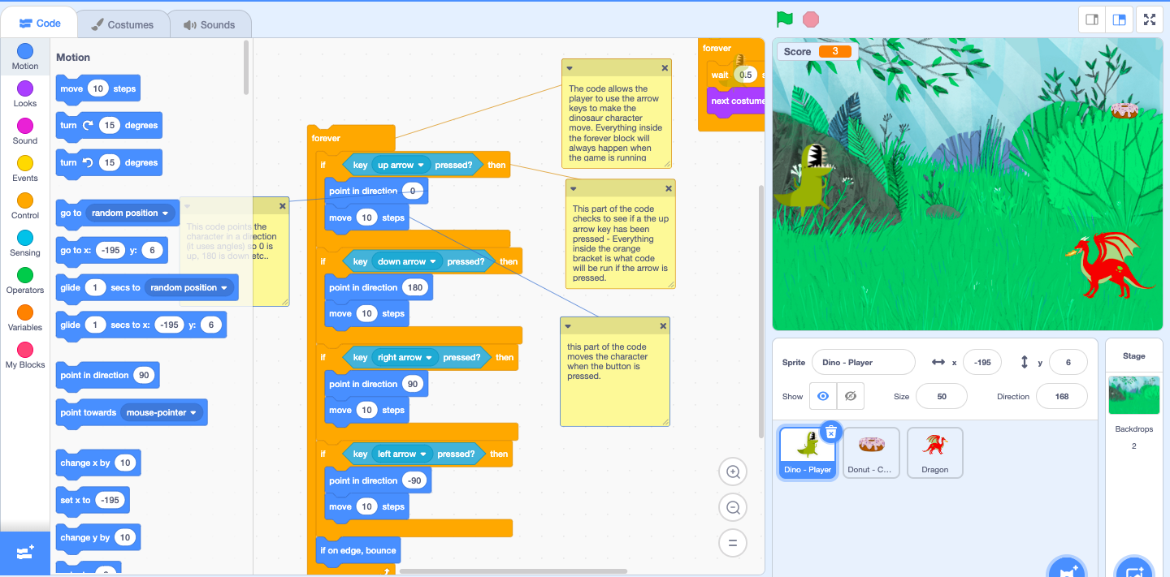

Additional suggested activities for starters, plenaries and home learning:

- BBC Bitesize - How do computer programs use variables?

Year 6

Unit 6.1 - Computing systems and networks – Communication

In this unit, the class will learn about the World Wide Web as a communication tool. First, they will learn how we find information on the World Wide Web, through learning how search engines work (including how they select and rank results) and what influences searching, and through comparing different search engines. They will then investigate different methods of communication, before focusing on internet-based communication. Finally, they will evaluate which methods of internet communication to use for particular purposes.

N ICT Guidance

Key Resources:

- School360 Google Suite (Google slides/ docs) Option to use Google classroom to collate work and resources. Further guidance around creating and using Google classroom available in School360 - Resources - Teacher Pack.

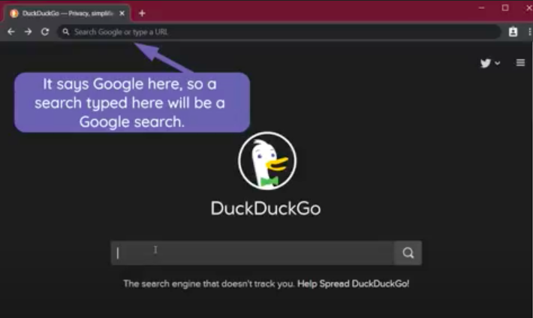

Additional suggested activities for starters, plenaries and home learning:

- BBC Bitesize - How Do Search Engines Work? has lots of activities that can be used to support this topic.

Unit 6.2 - Creating Media – 3D Modelling

During this unit, learners will develop their knowledge and understanding of using a computer to produce 3D models. Learners will initially familiarise themselves with working in a 3D space, including combining 3D objects to make a house and examining the differences between working digitally with 2D and 3D graphics. Learners will progress to making accurate 3D models of physical objects, such as a pencil holder, which include using 3D objects as placeholders. Finally, learners will examine the need to group 3D objects, then go on to plan, develop, and evaluate their own 3D model of a photo frame.

N ICT Guidance

Key Resources:
- 3D printers available for loan to SLA1 schools - Booking in advance required.
- 3D printer introductory course available to all SLA1 schools.
- Teachers can create a Tinkercad account (free) using a School360 account (login with Google - username@school360.co.uk) - this then allows a Tinkercad class to be created and students can join using School360 accounts with a unique class code allowing the teacher to view designs created digitally (this can be shared through Google Classroom).
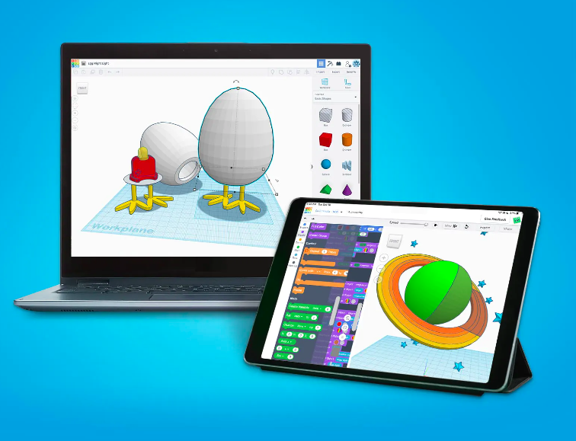
- Great opportunity to create cross curricular links with Science and resistant materials etc, around the use of shapes and materials.

Additional suggested activities for starters, plenaries and home learning:
- Google Sketchup - Downloadable option if needed.

Unit 6.3 - Creating media – Web page creation

This unit introduces learners to the creation of websites for a chosen purpose. Learners identify what makes a good web page and use this information to design and evaluate their own website using Google Sites. Throughout the process learners pay specific attention to copyright and fair use of media, the aesthetics of the site, and navigation paths.

N ICT Guidance

Key Resources:
- Google Sites using School360 accounts for students to create their own hosted websites.
- Designs / planning can all be created using Google suite (Docs and Slides) With the option of using Google classroom to collate all learning materials.
- Royalty free image search engine: Pixabay

Additional suggested activities for starters, plenaries and home learning:
- Busy Things - Computer Literacy and ICT tools
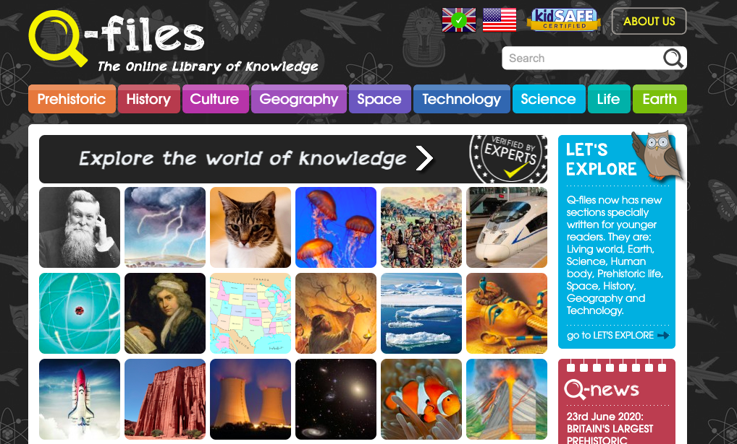
- Encyclopedia(s) - Access through School360 Resources: ‘Q-Files’ and ‘DK findout’ to research content for website.

Unit 6.4 - Data and Information - Spreadsheets

This unit introduces the learners to spreadsheets. Learners are supported in organising data into columns and rows to create their own data set. They are taught the importance of formatting data to support calculations. Learners are introduced to formulas and begin to understand how these can be used to produce calculated data. They are taught how to apply formulas which include a range of cells and apply formulas to multiple cells by duplicating them. Learners use spreadsheets to plan an event and answer questions. Finally learners create graphs and charts and evaluate their results in comparison to questions asked.

N ICT Guidance

Key Resources:

- School360 Google Suite (Google sheets) Option to use Google classroom to collate work and resources. Further guidance around creating and using Google classroom available in School360 - Resources - Teacher Pack.
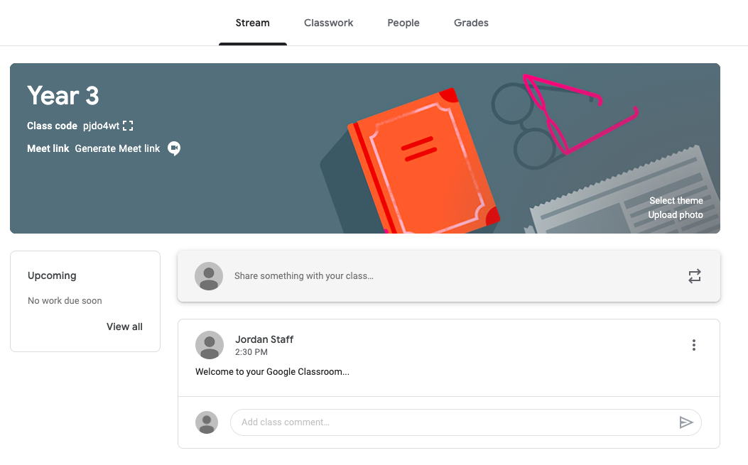

Additional suggested activities for starters, plenaries and home learning:
- BBC Bitesize: Creating and understanding charts

Unit 6.5 - Programming A - Variables in Games

This unit explores the concept of variables in programming through games in Scratch. First, pupils will learn what variables are, and relate them to real-world examples of values that can be set and changed. Pupils will then use variables to create a simulation of a scoreboard. In Lessons 2, 3, and 5, which follow the Use-Modify-Create model, pupils will experiment with variables in an existing project, then modify them, then they will create their own project. In Lesson 4, pupils will focus on design. Finally, in Lesson 6, pupils will apply their knowledge of variables and design to improve their game in Scratch.

N ICT Guidance

Key Resources:
- Use of School360 Google Suite (Google slides/ docs) Option to use Google classroom to collate work and resources.
- Teachers encouraged to create a Scratch teacher account using School360 account - students can join the class using class code - option to share through Google classroom, using this option allows teachers to view the students work. Further guidance around creating and using Google classroom available in School360 - Resources - Teacher Pack.

Additional suggested activities for starters, plenaries and home learning:
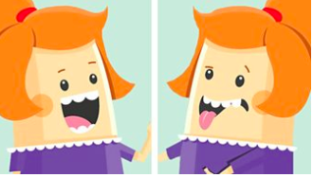
- BBC Bitesize - How do computer programs use variables?
- BBC Bitesize - What makes a good computer game?
- BBC Bitesize - How do you design a good character?

Unit 6.6 - Programming B - Sensing

This unit is the final KS2 programming unit and brings together elements of all the four programming constructs: sequence from year 3, repetition from year 4, selection from year 5 and variables, introduced in year 6, programming A. It offers learners the opportunity to use all of these constructs in a different, but still familiar environment whilst also utilising a physical device - the micro:bit. The unit begins with a simple program which learners build in and test in the programming environment before transferring it to their micro:bit. Learners then take on three new projects in lessons 2, 3 and 4, with each lesson adding more depth.

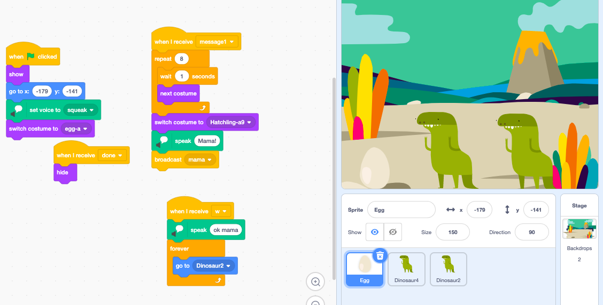

N ICT Guidance
Key Resources:
- Use of School360 Google Suite (Google slides/ docs) Option to use Google classroom to collate work and resources.
- Teachers encouraged to create a Scratch teacher account using School360 account - students can join the class using class code - option to share through Google classroom, using this option allows teachers to view the students work. Further guidance around creating and using Google classroom available in School360 - Resources - Teacher Pack.

Additional suggested activities for starters, plenaries and home learning:
- Recap from previous units:
  - BBC Bitesize - How do computer programs use variables?
  - BBC Bitesize - What makes a good computer game?
  - BBC Bitesize - How do you design a good character?
  - BBC Bitesize - What is debugging?

